# Лаб.4 - Crack the PIN

**Єлін Євген РІ-41мн**

<https://github.com/YelinYevgen/lab-4.git>

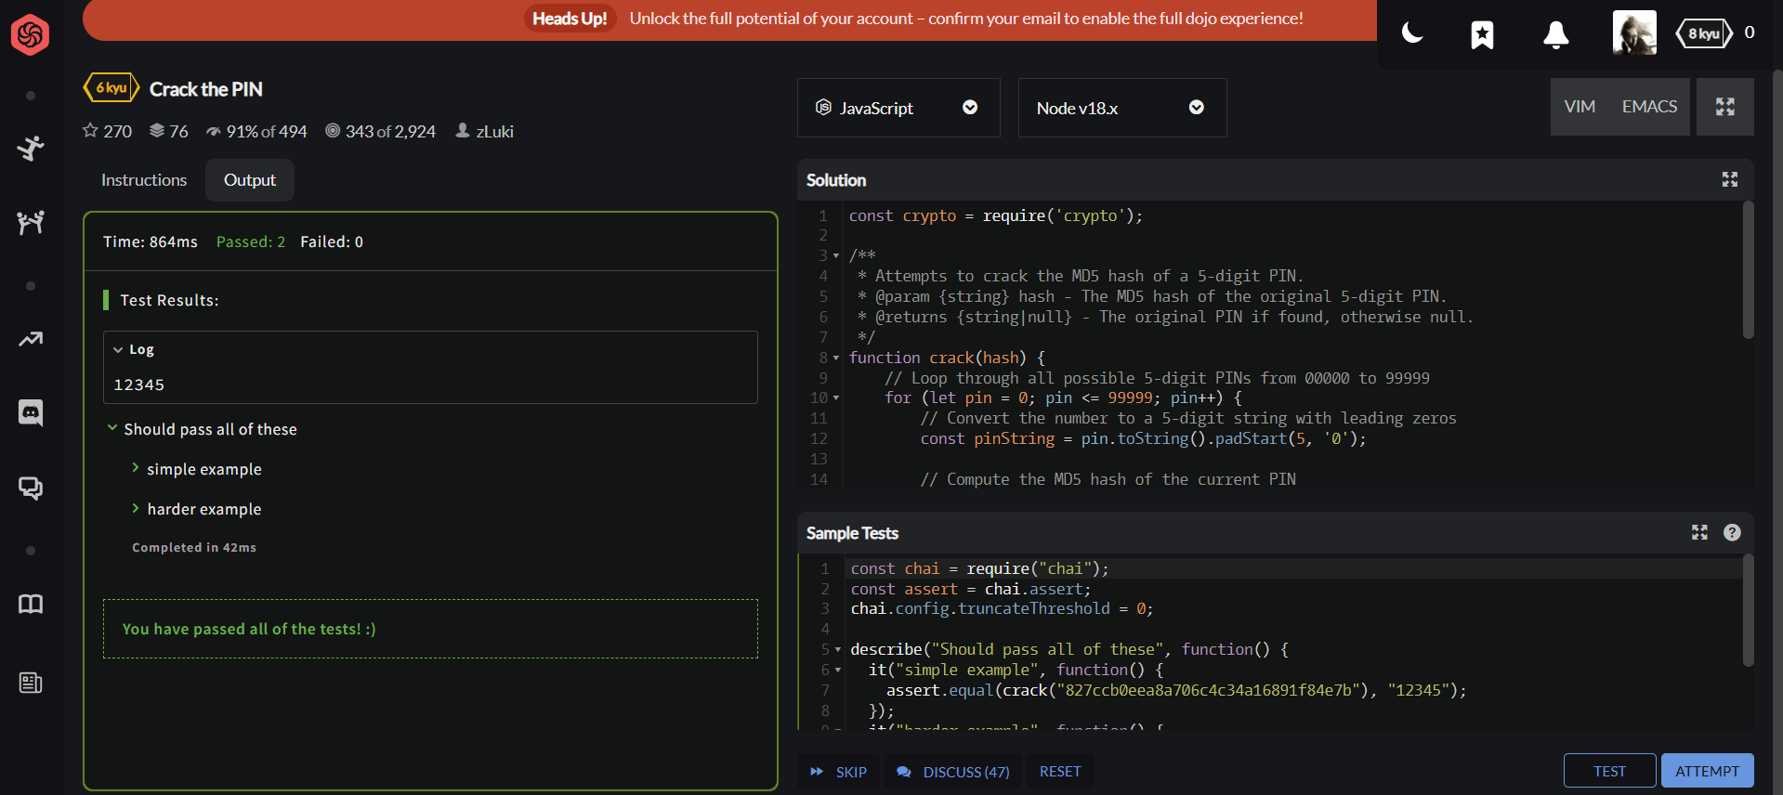

**Код на JavaScript:**

const crypto = require('crypto');

/**

* Attempts to crack the MD5 hash of a 5-digit PIN.

* @param {string} hash - The MD5 hash of the original 5-digit PIN.

* @returns {string|null} - The original PIN if found, otherwise null.

*/

function crack(hash) {

// Loop through all possible 5-digit PINs from 00000 to 99999

for (let pin = 0; pin <= 99999; pin++) {

// Convert the number to a 5-digit string with leading zeros

const pinString = pin.toString().padStart(5, '0');

// Compute the MD5 hash of the current PIN

const computedHash = crypto.createHash('md5').update(pinString).digest('hex');

// Check if the computed hash matches the target hash

if (computedHash === hash) {

return pinString; // Return the PIN if a match is found

}

}

return null; // Return null if no matching PIN was found

}

// Example usage (you can replace the hash with your test case):

const exampleHash = '827ccb0eea8a706c4c34a16891f84e7b'; // This is the MD5 hash for "12345"

console.log(crack(exampleHash)); // Should output "12345"